**Git and Github**

**Aditya Yadav**

**SECTION-3 - (JavaScript assignments)**

Steps to follow:

1. Create a new branch ‘js-assignments’.

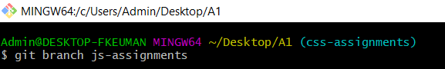

2. Switch to ‘js-assignments’ branch.

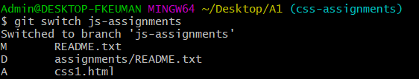

3. Copy all JavaScript assignments inside ‘Assignments’ folder.

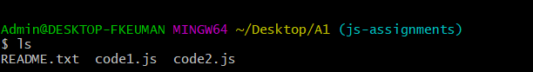

4. Commit JavaScript assignments into ‘js-assignments’ branch.

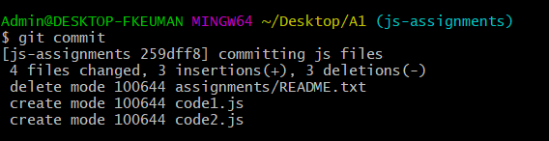

5. Make minor changes into README.txt file on line 1 belonging to ‘js-assignments’ branch.

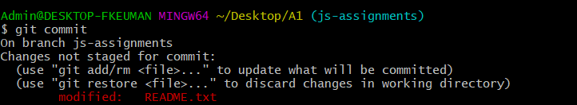

6. Commit those changed files.

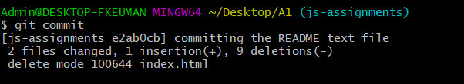

7. Switch to master branch.

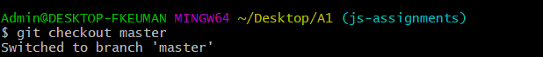

8. Make minor changes into README.txt file on line 1 & commit those changes into

master.

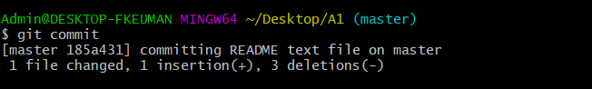

9. Again switch to ‘js-assignments’ branch.

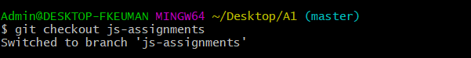

10. Make minor changes into few files belonging to ‘js-assignments’ branch.

11. Commit those changes. 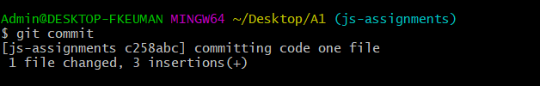

12. Switch to master.

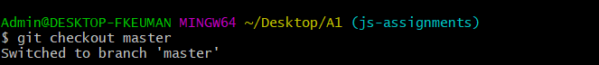

13. Merge ‘js-assignments’ branch into master. Confirm all JavaScript assignments are

shown in master.

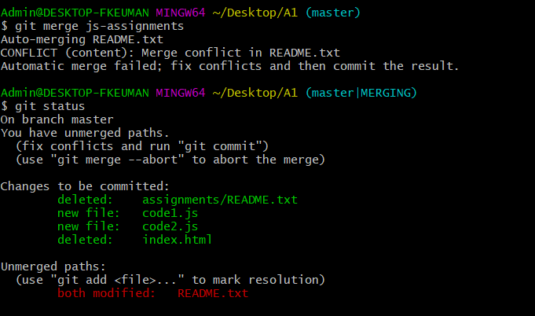

14. Finally delete the ‘js-assignments’ branch.

